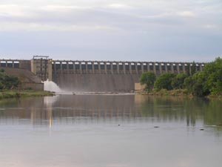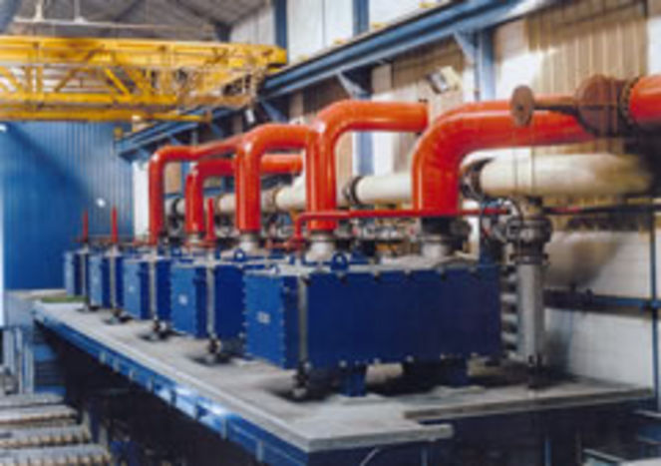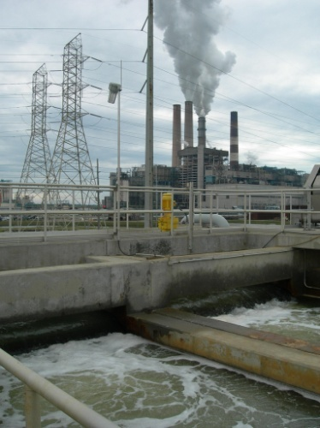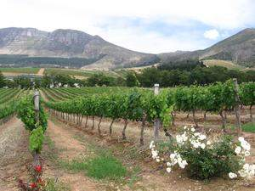

Project to Revise the Pricing Strategy for Water Use Charges and Develop a Funding Model for Water Infrastructure Development and Use and a Model for the Establishment of an Economic Regulator

Assessment of Institutional Options for Infrastructure Financing

Concept Note - Version 2.2

February 2013 WP10465

Table of Contents

1 Introduction 1

1.1 Purpose of this Concept Note 1

1.2 Scope of the Institutional Assessment 1

1.3 Structure of the Note 2

2 Scope of the Funding Options 3

2.1 Institutional Arrangements for Infrastructure Management 3

2.1.1 Department of Water Affairs 4

2.1.2 TCTA 4

2.1.3 Water Boards 5

2.1.4 Municipalities 5

2.1.5 Water User Associations 6

2.1.6 Users 6

2.2 Types of Infrastructure Projects Requiring Capital Funding 7

2.2.1 National and Regional Water Resources Infrastructure 7

2.2.2 Local Surface and Ground Water Resources Schemes 7

2.2.3 Water Conservation and Demand Management Interventions 8

2.2.4 Sea Water Desalination and Effluent Reuse 8

2.2.5 Water Quality Mitigation 8

2.2.6 Green Infrastructure 9

2.3 Sources of Financing 9

2.3.1 Fiscal Support (National Revenue Fund) 9

2.3.2 Public Sector Utility Reserves 10

2.3.3 Commercial Finance through Loans and Bonds 10

2.3.4 Equity Investment 11

2.3.5 Donor Support and Green Funds 11

2.4 Identification of Institutional Options 11

3 Principles and Criteria for Evaluating Institutional Options 13

3.1 Overview of the Principles 13

3.2 Proposed Evaluation Criteria for the Institutional Options 13

3.2.1 Institutional Complexity (and Governance Requirements) 14

3.2.2 Flexibility in Enabling Sources of Capital Financing 14

3.2.3 Financial Risk to Government 14

3.2.4 Operational Efficiency 14

3.2.5 Cost of Capital Financing 15

3.2.6 Applicability to Infrastructure (and Strategic Imperatives) 15

3.2.7 Alignment to Water Management (Service Delivery) Imperatives 15

4 Institutional options for financing capital investment 16

4.1 Option 1: DWA Infrastructure with Fiscal Support 16

4.2 Option 2: Ring-fenced Project with Commercial Financing 17

4.3 Option 3: Project Financing Entity with Revenue Collection 18

4.4 Option 4: Infrastructure Utility with Balance Sheet 19

4.5 Option 5: Public Private Partnership with Shared Equity 20

4.6 Option 6: Private Concession 21

5 Recommendations for the Way Forward 23

# Introduction

## Purpose of this Concept Note

The Department of Water Affairs (DWA) has undertaken a project to revise the Pricing Strategy for water use charges and to develop a Funding Model for water infrastructure development and use. As part of the same project they want to develop a model for the establishment of an Economic Regulator for the water sector.

The project takes place within a macro-context of the financial crisis, inequalities in South African society, municipal service delivery challenges, and increasing water scarcity. This task – the development of institutional options (or mechanisms) with which to finance water infrastructure – takes place within an immediate context characterised by: a general under-recovery of funds for refurbishment, contributing to a refurbishment backlog of over R10bn; a future build requirement in excess of R60 billion for water resources infrastructure development over the next 20 years; a need for non-traditional capital investment into projects that support water conservation, improve water quality, protect the environment and ensure long term sustainability of the resource; and a changing institutional landscape.

Early work in the project has focussed on obtaining a value and condition of all water resource infrastructure in the country, and determining the future needs. A working group has also been considering the principles that should be applied when determining how to fund water resource infrastructure. The next step is to develop a model that combines the existing asset base and associated revenue streams with the capital and operating requirements going forward, and to apply the principles in determining how these could be financed.

The purpose of this document is to consider six broad institutional models that can be used to secure funds for capital investment in order to guide the further development of the financing mechanisms and sources of finance for water resources infrastructure development in South Africa. It utilises the principles developed in the earlier documentation, along with evaluation criteria developed below, to assess the suitability of each model.

## Scope of the Institutional Assessment

At the outset it is important to distinguish the concepts of infrastructure financing and funding. The definitions used for this project are:

* ‘*Financing*’ is about managing cash-flow related to infrastructure development. It is concerned with raising the capital required to enable the initial investment in infrastructure.
* ‘*Funding*’ is about who ultimately pays for the infrastructure. It relates to paying for that capital (over time) as well as the subsequent operating costs required to sustain the infrastructure.

These concepts are intimately linked in practice, with the possibilities for financing being dependent upon funding. Nevertheless, this institutional assessment is primarily focused on the issue of water resources infrastructure financing and the possible institutional options (mechanisms or vehicles) that may be adopted to facilitate the financing of infrastructure development and operation.

As will be expanded upon in the next Chapter, these institutional options must enable the financing of various types of infrastructure and different sources of capital finance, each of which may have different requirements party related to funding by water users (tariffs), the fiscus (taxes) or external grants (transfers). Furthermore they must reflect government’s fundamental principles related to water management, fiscal prudence and institutional viability.

It is recognised that the distinction between water resources infrastructure and water service infrastructure is increasingly blurred, particularly for non-conventional infrastructure, and that the sustainability of user cost recovery is dependent upon effective delivery along the entire water infrastructure value chain. However, the ***mandate of this study and therefore this paper is the financing of water resource infrastructure***, so the focus will be on those elements of the value chain. The financing of water services infrastructure requires a similar, albeit distinct, assessment that addresses the specific constitutional mandate of local government water services delivery.

## Structure of the Note

The structure of the document is as follows:

* Chapter 2 expands on the scope of infrastructure finance, in terms of the types of infrastructure and the sources of finance.
* Chapter 3 reviews the principles for water infrastructure financing and translates these into criteria against which the institutional-financial options will be evaluated.
* Chapter 4 provides a preliminary evaluation of the institutional options against the identified criteria.
* Chapter 5 provides a brief summary and recommendations about the further evaluation of institutional arrangements and financing mechanisms.

# Scope of the Funding Options

This Chapter outlines the types of infrastructure and the sources of capital financing that must be considered in the definition of the institutional options. However, it begins with a brief review of the current institutional arrangements in the water sector within which the option(s) will need to operate.

## Institutional Arrangements for Infrastructure Management

The institutions involved in the development and management of water resource infrastructure are indicated in Figure 1 below.

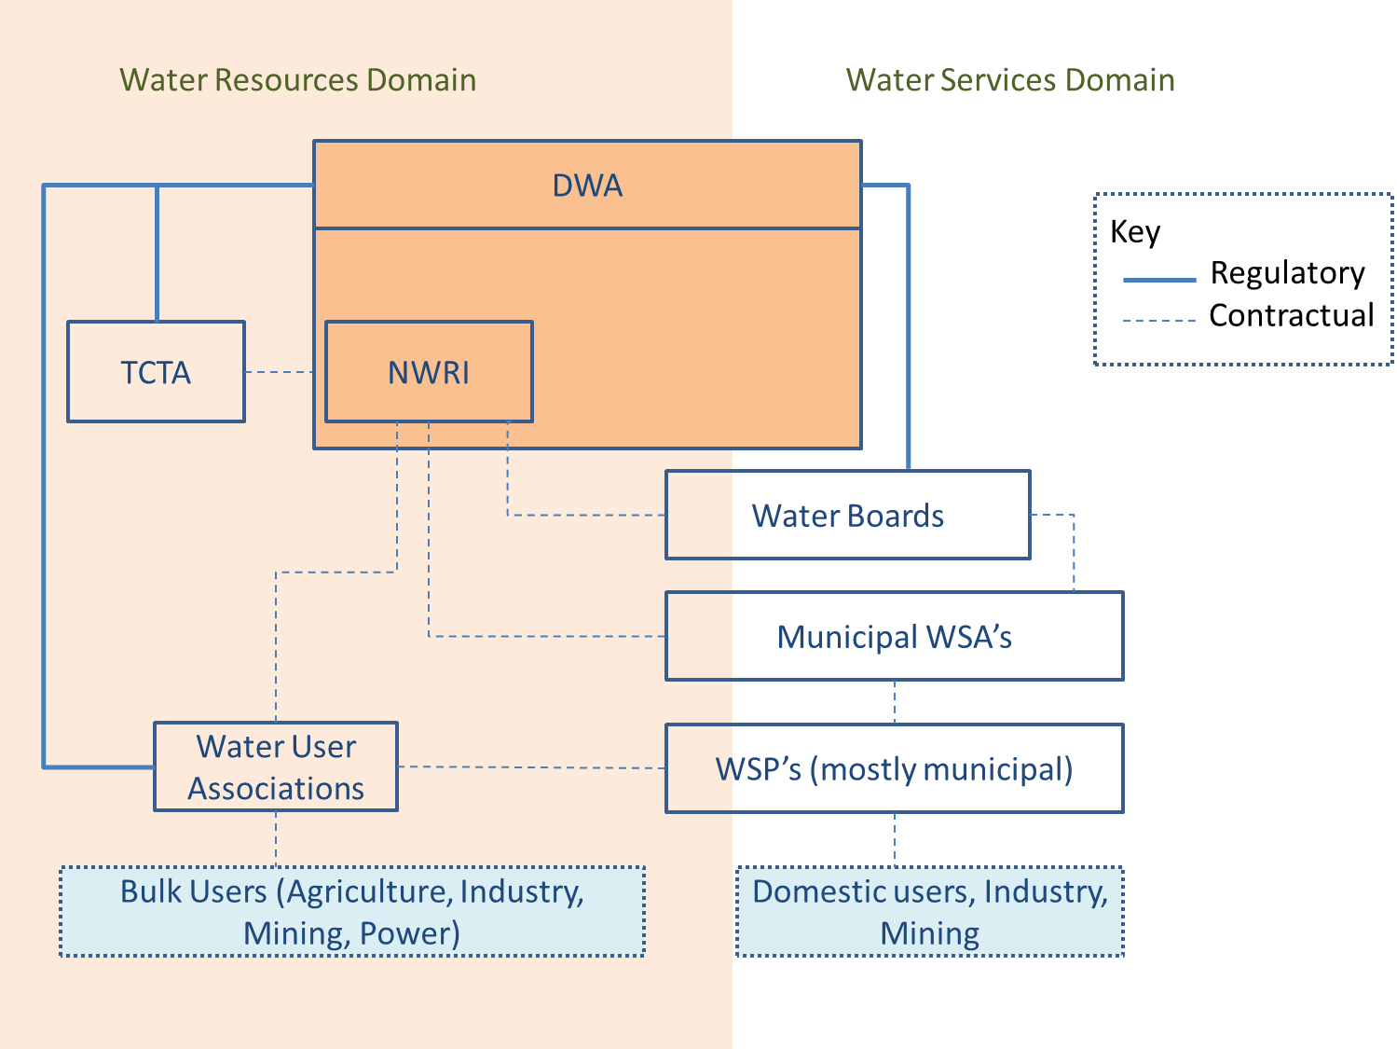

Figure 1: Institutions in the water resource sector

We are mainly concerned with the DWA and TCTA in this (water resource focused) analysis, although Water User Associations also play a role. Water Boards and municipalities, whilst primarily operating in the water services space, may also have water resource infrastructure such as small dams, desalination plants and acid mine drainage infrastructure.

The solid lines represent regulatory relationships where DWA practices institutional oversight. The dotted lines represent contractual relationships – either involving the provision of water, or the collection of revenue on behalf of DWA or TCTA.

Each of the above institutions is briefly described below (further detail is available in earlier submissions if required).

### Department of Water Affairs

The Department of Water Affairs has three main types of responsibilities listed below. In order to fulfil these responsibilities, DWA plans, funds, constructs, maintains and operates the water resources infrastructure as well as sets and recovers water use charges.

Responsibilities:[1]

* DWA is the custodian of the water resources of the country and is thus responsible for the allocation and health of the country's water resources;
* DWA has a trusteeship role and is thus responsible to care for the country’s water resource infrastructure; and
* DWA has a regulatory and oversight role

DWA, through its Water Trading Entity (WTE) manages the National Water Resource Infrastructure (NWRI) held in the trading accounts. This infrastructure is considered of national significance and is considered beneficial to operate, maintain and develop at a national level.

Funding for the schemes and systems is through revenue generated from water resource infrastructure users and augmentation from the fiscus when insufficient revenue is generated to cover the general operations and develop new infrastructure.

Infrastructure that is funded on-budget is implemented through the Infrastructure Branch of the Department. Some of the infrastructure costs are expected to be recovered through the Infrastructure charge as determined by the Pricing Strategy. This charge is scheme based and consists of three elements:

* Operations and Maintenance (O&M)
* Depreciation
* Return on Assets (ROA)

The O&M charge is based on the actual cost of operating and maintaining the particular scheme. The depreciation and ROA are based on the asset replacement value (or cost) of the scheme, with the ROA being fixed at 4%. The aim of the depreciation charge is to fund the rehabilitation of assets to their original value, while the ROA is meant to fund the betterment of existing assets and the development of new social waterworks.

Through its Institutional Oversight unit, the Department regulates and oversees the performance of the TCTA, Water User Associations and Water Boards.

### TCTA

The Trans-Caledon Tunnel Authority (TCTA) is a state-owned entity that raises finance for major water resource projects and then manages the design and construction of the infrastructure. It is empowered to raise funds from the domestic and international money markets. Over the past 20 years, about R21 billion of investment in the Lesotho Highlands, Berg River Dam, and the Vaal River Augmentation projects has been funded from commercial sources (predominantly the bond market) through TCTA. TCTA mostly funds the implementation of infrastructure through debt funding raised from the private sector and from other funding agencies such as the DBSA.

TCTA’s mandate derives from explicit directives from the Minister of Water and Environmental Affairs and is generally to develop infrastructure that has a high degree of economic utilisation, the expectation being that TCTA will be able to recover the full cost of the infrastructure without having to resort to government grants or transfers. This is often referred to as ‘off budget’ financing in that the capital costs are financed not from the National Revenue Fund (and the national budget allocation) but from alternative sources such as loans raised directly by the public entity.

Some of the more recent projects, such as Olifants, do have an element of social use, and this may have an impact on TCTA’s financing model going forward.

Some of the key characteristics of the TCTA model:

* Financing is off-budget – i.e. not reliant on allocations from the National Revenue Fund,
* Financing relies only on implicit guarantees from Treasury (excluding Lesotho Highlands (LHWP), which is explicitly guaranteed)
* All projects are ring-fenced, i.e. no cross-subsidisation is allowed
* Debt repayment is funded through water tariffs, over 20 years
* TCTA’s up front deficits on a project are intended to ensure on-going affordability for end users; the deficit reverses after a few years, and is not related to TCTA’s feasibility as a going concern.

### Water Boards

Water boards are state entities created by the Minister of Water Affairs in terms of Chapter VI of the Water Services Act. Their primary activity is the provision of bulk potable water services to local authorities that depend on a common source of raw water. Their services may also extend to the treatment of waste water.

The 12 water boards vary greatly in size and in technical and financial capacity. Rand Water is as large as all the other water boards put together. Rand Water and Umgeni Water together constitute 84% of water board assets (as at March 2011).

A water board must strive to be financially independent and to this purpose must negotiate and set tariffs that ensure the financial sustainability of the water board. Debt collection is a major concern for most water boards. In 2011, it was estimated as shown in the table below, that 12 water boards were owed a total of R2.1 billion by municipalities.

To summarise, Water Boards play a limited role in water resource infrastructure development. Their development of bulk infrastructure is largely financed by off-budget sources, although this has been placed under some pressure due to delayed payment by municipalities and borrowing restrictions imposed by National Treasury.

### Municipalities

The financial business model of a water service authority is closely regulated by the Municipal Finance Management Act, 2003 (MFMA). Finance decisions are preceded by the integrated development planning process required by the Municipal Systems Act. The water services development plan (WSDP) required by the Water Services Act becomes part of the IDP. A local authority may only budget for capital items that are included in the IDP.

National Treasury’s Review of Local Government Revenue and Expenditure indicates an increased reliance on national government transfers to fund local government’s infrastructure investment. Whilst borrowing has increased over the past 5 years, this has been driven by the public sector (almost exclusively the Development Bank of Southern Africa (DBSA)). Private lenders became more risk averse after the recession in 2008

To date, only the City of Cape Town, Johannesburg and Ekurhuleni have issued municipal bonds (totalling R11.8bn). Bonds have the benefit of allowing municipalities to negotiate the payment periods and interest rate payments whilst offering investors better interest rates than most other savings schemes.

To summarise, the financing of municipal infrastructure is dominated by direct on-budget support from the fiscus and internal sources. At the same time the larger Metros have demonstrated their ability to raise off-budget finance through the bond market, whilst the DBSA has effectively played the role of ‘debt pooler’ for the broader municipal sector.

### Water User Associations

A WUA derives its mandate from the National Water Act, which describes a WUA as a “co-operative association of individual water users” who for the purpose of common gain, carry out water-related functions. Only the Minister of Water Affairs, in accordance with the prescriptions of the Act, can establish or disestablish such an association.

Water User Associations (and their pre-cursor: Irrigation Boards) are entitled to set charges/levies on their members to recover the costs of administration, operation, depreciation and debt repayment of their own schemes, following the requirements of their constitutions. Where they are responsible for the operation of government water schemes, they can act as billing and/or implementing agents for DWA. Some irrigation boards/water user associations have outstanding pre-1994 loans with the Land Bank, while some have taken commercial loans for infrastructure development. There have been difficulties in repayment of all of these debts by farmers over the past decade, which has restricted the willingness of banks to provide loans. Current government policy is that the state will no longer underwrite either private sector or Land Bank loans.

### Users

Whilst users are not part of the institutional arrangements, they are critical to understanding the relationships as they determine the primary source of revenue. COGTA, through its administration of the Municipal Infrastructure Grant, and National Treasury, through its allocation of on-budget funding, are also relevant.

The end users of water resource infrastructure are either bulk users such as power and mining, agriculture (normally through water user associations), and domestic users (after water has normally passed through a water board as well as the water service provider). Of relevance is that costs imposed on end users for water resource infrastructure must also consider the additional downstream costs that will be added to the final tariff.

Of equal relevance is the distance between the owner of the water resource infrastructure and the collection of the tariff from the end user. If there are intermediaries (such as Water Boards and WSPs) then it increases the risk that not all revenue will be collected.

## Types of Infrastructure Projects Requiring Capital Funding

The nature of water infrastructure required to meet current and future water requirements is evolving from traditional large surface water reservoir systems to a diverse array of conventional augmentation and non-conventional interventions, related to demand management, water reuse, desalination, waste mitigation, water conservation and green (natural) infrastructure. Many of these blur the distinction between water resources and water services, and thus the institutional responsibilities for development, operation and funding.

Capital finance is required for new development, betterment (improving yield) and/or rehabilitation of existing infrastructure (that has deteriorated due to lack of maintenance), while operation and maintenance costs differ significantly between these options.

### National and Regional Water Resources Infrastructure

Proposed new national and regional water resources infrastructure schemes tend to be multi-purpose in nature, albeit with a focus on supply to domestic, industrial, mining or energy users. This is primarily the responsibility of DWA NWRI and possibly Water Boards under mandate to the Minister.

The total projected build over the next 10-20 years, as per the National Water Resource Strategy, is R76bn off a current replacement cost of R146 bn for the existing assets. Projects under planning (pre-feasibility/feasibility phase) are estimated to cost an additional R37 billion.

Long-term deterioration of the existing national and regional water resources infrastructure has led to a R10 billion rehabilitation backlog required to restore the existing asset to adequate functioning and meet public safety requirements.

### Local Surface and Ground Water Resources Schemes

Local water resources infrastructure tends to be single-purpose in nature, supplying domestic rural, municipal urban or agricultural irrigation systems; small local hydropower schemes also fit in this grouping. It is expected that proposed new infrastructure would be developed, financed and operated by the relevant local water institutions, which are typically municipalities, water boards or water user associations. The distinction between water resources and bulk water supply (or services) infrastructure is seldom useful at this scale, as they are typically part of a single irrigation or water services scheme. Despite local responsibility, there may be some technical or financial support required from national government.

The projected development requirements of this local infrastructure are uncertain, but may be as much as R 38 billion over the next 10 years. This may be compared to the estimate of R 51 billion for the existing local water resources assets owned by national government and the estimated R60 billion owned by other water institutions. Together these have an estimated rehabilitation backlog of about R10 billion.

This does not even include the onsite water resources infrastructure owned by individual agricultural, mining and industrial users. Nor does it include the far greater water services assets owned by water boards and local government, estimated at R 970 bn. Here again the refurbishment backlog is believed to be significant.

### Water Conservation and Demand Management Interventions

In a water scarce country such as South Africa, water conservation and demand management measures are an important element for reconciling water requirements with availability. Importantly demand management also provides a short term option to reduce demand where demand growth has outstripped the assurance of supply of the existing infrastructure, before new augmentation options can be implemented. While some demand management measures involve social and awareness interventions, many have capital infrastructure investment requirements to modify, retrofit or even rehabilitate supply systems.

Many South African municipal water (services) supply systems have unacceptably high water losses (above 40% non-revenue water), with viable infrastructural interventions to support demand management (such as pressure reduction and zonation). Typically these are improvements of existing water services systems or even on-site retrofitting of private facilities or households, which have relatively short payback periods at a system scale (between 2 and 5 years). Estimates of the water demand management investment required over the next decade are between R2bn and R3.5bn.

On the agricultural side, on-site demand management is a farmers’ responsibility, but there are irrigation scheme interventions that may require joint investment by Water User Associations, some of which may need to be facilitated by National Government. Accurate estimates of the potential investment in agricultural demand management are not widely available, but would exceed the urban demand management interventions when shifts in irrigation technology are considered.

Institutionally it is important to recognise that while these interventions have important public water resources reconciliation benefits, they are the responsibility of water services institutions or private sector water users. Therefore financing these interventions is often complicated by institutional fragmentation along the water value chain.

### Sea Water Desalination and Effluent Reuse

Limited further sources and the steadily rising marginal costs required to conventionally augment water supplies, has resulted in non-conventional schemes becoming viable. In particular, this has led to implementation of projects to desalinate sea water for supply to coastal areas and the reuse municipal (or industrial) effluent to augment industrial and domestic supplies.

Typically the capital financing requirement of these projects ranges from R20m (Plettenberg Bay) to R2 billion (eThekwini), with up to R3 billion being considered across the country over the next decade. However, as with demand management, the institutional responsibilities for these projects are unclear. They provide augmentation of water supply with the related impact on water resources infrastructure, but at the same time they are integrally linked with the bulk water supply and waste water (services) systems.

### Water Quality Mitigation

Acid mine drainage and deteriorating water quality in many South African catchments has led to the development of a waste discharge charge systems and the possibility of measures designed to mitigate the water quality impacts on downstream water resources and users. The capital financing requirements of infrastructure-related measures can be significant, particularly for schemes like the regional collection and treatment of mine decant and/or dewatering.

While planning for these types of initiatives are in their infancy in South Africa, their implementation and financing requirements are likely to increase over the next decade. By way of example the recently constructed Emalahleni scheme cost R300 million to construct and the proposed West-Rand AMD schemes are expected to cost R924 million.

Again there are institutional challenges around the mandated institution to develop, finance and operate these schemes that typically have private sector, local municipality and/or national government involvement.

### Green Infrastructure

Functioning water resources and catchment ecosystems provide flow attenuation and waste assimilation functions. Rehabilitation or enhancement of degraded natural infrastructure may contribute to supply augmentation or mitigate water quality impacts. This may include wetland restoration, riparian zone protection and alien vegetation clearing. Projected investment in water-related alien clearing, wetland protection and catchment restoration is estimated to be in the order of R8 billion to R10 billion over the next decade.

Capital investment for these projects differs from built infrastructure in that the state has custodianship over the ecosystem, it may be on private land owned by individuals involved in other activities, it may be complex to attribute the improvement in system functioning at a project (rather than system) level, and there are often other important social and biodiversity benefits. This poses institutional challenges to financing the intervention. While this is not a focus of this note, it has been included for completeness.

## Sources of Financing

The focus of this note is on the capital finance required to fund the development and possibly the initial operation (working capital) of the abovementioned infrastructure. Ultimately, the funding of ongoing operations and the repayment of capital (with possible returns) for the infrastructure will be by the specific users (or beneficiaries), from general taxation (the fiscus) or external support from global donors. The source and viability of this funding is a critical consideration in the relevance of different capital funding sources for a specific infrastructure project, which will be expanded upon later in this note. Before this though, it is important to outline the sources of financing, distinguishing between public sector, private sector and donor sources.

It is important to note that a specific project may be financed using more than one of these sources, depending upon the purpose and nature of the infrastructure and the institutional option that is used to enable the financing.

### Fiscal Support (National Revenue Fund)

Globally, most water resources infrastructure is financed through the fiscus (supported by donor transfers in the developing world). This remains an important source of finance for the South African water, particularly in support of social or regional economic development imperatives.

For the purposes of water resources infrastructure development, it is not relevant whether this is obtained through general taxation or treasury bonds. It should be highlighted that the introduction of the proposed waste discharge charge system may enable the collection of waste discharge levies into the National Revenue Fund, which may be implicitly earmarked for water quality mitigation projects. All decisions to finance water resources infrastructure from the fiscus (National Revenue Fund) are done within the national budgetary constraints of the Medium Term Expenditure Framework (MTEF), with the associated tradeoffs between government’s developmental priorities and considerations in terms of government’s infrastructure investment programme.

Importantly, strictly water resources infrastructure appropriation would be channelled through DWA’s budget, either to DWA NWRI Branch or any relevant water management institution acting as an agent for government. A total of R11.4 billion has been allocated from the fiscus to support water resources infrastructure development over the past 5 years (with an additional R7.7bn allocated to regional bulk infrastructure), and the Department’s multi-year Strategic Plan indicates that this level of funding support is likely to continue over the next 5 years. However, fiscal financing of the expansion or refurbishment of more water services-related infrastructure may be channelled to municipalities through other infrastructure investment/grant programmes.

### Public Sector Utility Reserves

Public sector institutions may build capital reserves though tariffs that are designed to exceed costs, which are intended to be used for infrastructure expansion, upgrading or refurbishment. Many of the Water Boards have built significant reserves on their bulk tariffs for expansion or to meet interest cover requirements on existing debt (total of R 13 billion in Reserves in 2011 for all 12 water boards) and a few water user associations (WUA) have built reserves for rehabilitation of existing schemes. While DWA NWRI should build (and even roll-over) reserves associated with the ROA and depreciation charges designed for social development and refurbishment, there has historically been an limited reserve accumulation by DWA in the Trading Entity because total charge recovery has generally only met operation and maintenance costs. Municipalities and their utilities may also build reserves, but these are currently quite limited (for political reasons) and are less likely to be allocated to water resources related infrastructure.

Allocation of these reserves is fundamental to the entities’ business planning process, linked to the infrastructure development and refurbishment requirements, as well as the tariff setting process. Institutionally, allocation of these reserves is only appropriate where the water infrastructure is part of the core mandate of the relevant institution.

### Commercial Finance through Loans and Bonds

The recent practice for financing water resources infrastructure that is economically viable, has been to access commercial sources of finance through loans or bonds. The critical requirement for this debt is the sustained income stream that the associated asset/s can generate to repay the capital and interest. Importantly the cost of this capital (interest rate) depends on the estimated investment risk, which considers aspects from sovereign and exchange risk, through the approach to developing and managing the project asset by the implementing agent, to the reliability of the income associated with the nature of water users/customers or implied cashflow guarantees.

Various instruments may be used to raise this capital, from commercial bank loans to dedicated bonds. The selection of these instruments depends upon the nature of the project, as well as the mandate, balance sheet and credibility of the water institution raising the debt. Development banks (such as WB, AfDB and DBSA) and finance institutions (such as IDC, LandBank, etc) may also provide debt, either at commercial interest rates or through reduced-interest “soft” loans, particularly for socially or environmentally beneficial projects. On the other hand, development banks and finance institutions have relatively well developed public sector infrastructure risk management protocols, commercial financiers often rely on these agencies to scope and mitigate lending risks.

Institutionally debt must be raised by mandated public entities or special purpose vehicles, typically with the concurrence of the Minister of Finance. There are two fundamentally different approaches that may be adopted, namely (i) to raise specific debt on a ring-fenced project basis against the expected income stream for that project, or (ii) to raise general debt for one or more projects against the entity’s balance sheet and associated total net income stream from multiple projects.

In South Africa, the TCTA has been the primary vehicle for raising ring-fenced project-specific finance for national water resources infrastructure (currently with about R18 billion of debt across 10 projects), with an implicit guarantee for DWA to collect and repay the debt). Water Boards also raise capital from commercial sources (currently they have R3 billion in debt) against their projected income, while some WUA have accessed capital finance against surety by the farmers. A few of the larger creditworthy municipalities (particularly metros) have also raised debt for general infrastructure investment.

### Equity Investment

Equity investment by the private sector may be through a public-private partnership (PPP) or an entirely private concession. On the extreme, equity may include funds buying equity in a project or public utility through to entirely private development initiatives, neither of which is particularly likely in the South African water resources environment. The purpose is to share the risk of investment and return, but require that the private investor has more commercial control over the investment, as well as development and operating decisions (to manage this risk).

While equity models have not been adopted for the traditional South African water resources sector, they are extensively used internationally for water services and energy (including hydropower). They require the establishment of a special purpose vehicle with the relevant equity staked or may be implemented by an existing private utility for full concessions. They tend to be project based, reflecting the capital (equity) required for development of infrastructure.

It is worth noting that equity partnerships have been implemented for the non-conventional water services related infrastructure in South Africa, such as demand management interventions and effluent treatment (and reuse), and could be a source of financing for local desalination, hydropower and water quality mitigation projects without involving national strategic infrastructure.

### Donor Support and Green Funds

While South Africa does not receive significant donor support for water infrastructure development, this needs to be considered. In particular there are opportunities under the green and climate adaptation funding mechanisms that may be used to access capital for the additional costs of making infrastructure resilient to climate change and more environmentally sustainable. This area of capital financing needs more attention for the South African context, particularly given the South African climate negotiating position of not requesting these funds.

## Identification of Institutional Options

Building on the types of infrastructure required, the sources of finance and the existing institutional arrangements, there are six fundamentally different institutional options that may be considered:

* DWA (or public water institution as agent) developing and operating the infrastructure with capital allocated from the fiscus as part of the departmental budget (National Treasury).
* A project financing vehicle that raises commercial finance on a project basis, similarly to TCTA, but with operations performed by DWA and other utilities.
* An infrastructure financing entity to raise capital and develop infrastructure, based on the revenue from the existing infrastructure assets, but with operations by DWA.
* Infrastructure utility that finances, develops and operates water resources infrastructure off its balance sheet and the income it can generate from these.
* Public-private partnerships with for a specific project where private investors have some equity in the scheme, which is financed, developed and operated by the partnership vehicle.
* Concession to private sector financiers or water users to finance, develop and operate a scheme for a specified timeframe through their equity (and possibly debt).

This Chapter has outlined the broader institutional arrangements in the water sector, the types of water resources infrastructure requiring finance and the possible sources of this finance. These have been briefly translated into institutional options that enable the required financing of the planned infrastructure, which will be evaluated in Chapter 4. First however, the principles and criteria against which these options must be evaluated are discussed in the next Chapter.

# Principles and Criteria for Evaluating Institutional Options

The evaluation of institutional options to enable the financing of water resources infrastructure requires the development of evaluation criteria. These in turn must be based on the broader water management, fiscal and governance principles and imperatives driving infrastructure financing (outlined in the project report *Review of Principles and Experience for Infrastructure Finance*). This chapter reviews these principles and proposes evaluation criteria.

## Overview of the Principles

To start with these is a need for the principles to be built around an understanding of the strategic purpose of the infrastructure in the national, regional, local or private interest, distinguishing between financing needs for infrastructure providing water to:

* + commercial and economic users (upon which revenue can pay for the full financial costs);
  + social-developmental users or ecological requirements (which may not be able to afford the full financial costs of the infrastructure); and
  + regional development supply (which may require water infrastructure to be in place to enable/catalyse development, but no users are available in the short term).

This allows the interpretation of principles that are not necessarily evenly applied to these different groupings:

* Requirements to motivate fiscal support for infrastructure development
  + Operational efficiency in the development, operation and maintenance of the infrastructure, while recovering charges from those obliged to pay for the benefit.
  + Allocative efficiency in the tradeoffs between allocation of public money between different demands related to the developmental, social and economic benefit.
* Determination of viability of the project
  + Financial viability of the project, based on the full cost of the project
  + Social and economic viability needs to inform the financial viability for sources of finance
* Who pays
  + User pays is the default position
  + Affordability must be considered for social users, but requires subsidisation
  + Cross-subsidisation between users
* Time based allocation of fiscal support and associated mechanisms
  + Capital grants for social development purposes
  + Ongoing subsidies to meet the operating obligations of non-affordability.
* Sustainability
  + Financial at a project / system scale
  + Institutional to meet mandated obligations

## Proposed Evaluation Criteria for the Institutional Options

The preceding principles outline the imperatives for infrastructure financing and link to the principles underlying water pricing and the ultimate funding of infrastructure. However, in order to evaluate the appropriateness of the institutional options for infrastructure financing, these need to be translated into the key criteria related to the institutional complexity, flexibility, risks, applicability and alignment. It is important to note that these do not fully reflect the imperatives for infrastructure development and operation, but rather the ability to effectively finance infrastructure through given institutional-financial mechanism.

### Institutional Complexity (and Governance Requirements)

The degree to which the option builds on existing institutional arrangements or imposes additional transaction costs through the establishment or oversight of the institutions’ activities in financing, developing and possibly operating infrastructure. This relates to whether the option simplifies or complicates the existing institutional arrangements, and whether it addresses the disjoint between water resources and water services infrastructure. Related issues for considerations relate to: the *accountability* of the institution to government (Minister) or private shareholders; possible *legislative amendment* required to enable the institutional option; the institutional mechanisms for *mandating* infrastructure development and its operation, either through government decree, service level agreement or contract; and the regulatory *oversight* and transparency required for tariff setting to recover costs and build reserves, according to specified rules [Economic regulation].

### Flexibility in Enabling Sources of Capital Financing

A combination of all five sources of capital financing are likely to be required to meet South Africa’s water resources infrastructure development and rehabilitation challenge. The appropriate source of financing may differ according to the strategic purpose for which that infrastructure is required. Some institutional options cannot enable access to some of these sources, have limitations or conditions on the way in which some of these sources are accessed, or impose significant overhead costs or risks in accessing capital from some of these sources. Where the conditions of risks get too high, that institutional option would not be appropriate for infrastructure that requires that type of capital financing.

### Financial Risk to Government

Capital infrastructure investment has risk to the financial institution that provides the capital, as well as the institution/s that are mandated to collect revenue for operation of that infrastructure and to repayment of that capital (possibly with a return). Different options imply differential sharing of risk by the different institutional roleplayers, with the private sector requiring returns (profit or interest) that reflect risk. It is critical for government that its exposure to financial risk is managed, and the costs of service delivery are efficient. Uncertainty, complexity and inefficiency in institutional options and the associated mechanisms for project development and income collection increases risk, and so there are times that government provides guarantees to support project finance, in order to keep the cost of capital as low as possible. This imposes a (contingent) liability on the sovereign debt, which National Treasury would like to avoid where possible.

### Operational Efficiency

The delivery of services, the maintenance of infrastructure and the recovery of revenue are fundamental to the ability of a project or utility to repay money used in its development, operation and maintenance. The efficiency with which infrastructure is operated and costs are recovered along the entire water value chain is therefore fundamental to an assessment of the risk of a project to the financiers. At the time of infrastructure financing, this can only be based on prior experience, which is related to the track-record of the institutions responsible for the project development and operation. Similarly, it is not efficient for the fiscus to be allocated funds in perpetuity to cover inefficient operations. Improving operational efficiency must therefore be considered as the fundamental platform for efficient (low cost) infrastructure financing.

### Cost of Capital Financing

The repayment costs for infrastructure financing relate to the source of finance and the perceived investment risks. Higher risk requires greater returns, with uncertainty being the main driver of risk perception. Clarity in the rules governing tariff setting and repayment, and distinction between commercial-economic elements of the infrastructure and social-developmental elements are critical in managing this uncertainty. Money from Treasury bonds carry the lowest risk and therefore have the lowest interest, but must compete with all other social and economic expenditure. Utility or project debt tends to be higher and needs to demonstrate a reliable income stream (at investment grade), or will require some degree of guarantee on the income (or debt) to avoid escalating risk-related interest charges. Equity typically requires the highest returns (as profit), to account for the direct risk that is typically taken on the investment.

### Applicability to Infrastructure (and Strategic Imperatives)

A number of qualitatively different types of water resources related infrastructure were highlighted in the previous chapter. Each of them relate to different geographic scales and to different parts of the water value chain, which implies that the mandate and jurisdiction for infrastructure development and operation varies between these infrastructure types. As a consequence, different institutional models may be more or less applicable to the different types of infrastructure. The most important distinction will be between national government related water resources schemes and local government water services related infrastructure systems, with a grey area in between.

### Alignment to Water Management (Service Delivery) Imperatives

While the focus of this note is on the infrastructure financing aspects of the institutional option, the ultimate purpose is water management as custodian of the nation’s water resources, together with the delivery of services to customers (primarily water users). Convergence in responsibility for the financing, development and operation of infrastructure tends to reduce financial risk, but where this is not in the direct control of DWA (or conversely is influenced by private sector interests), this raises concerns around the management of that infrastructure in the public interest. These can be mitigated by effective infrastructure operating rules and service delivery agreements, but requires effective (capacitated) institutional and technical oversight.

# Institutional options for financing capital investment

## Option 1: DWA Infrastructure with Fiscal Support

This is the way that much of DWA infrastructure has been funded in the past. National Treasury allocates a share of the National Revenue Fund to DWA, which either directly invests in the required infrastructure, through its Infrastructure Branch, or by transferring the funds to an implementing agent. National Treasury sources its funds from annual taxation receipts, Treasury Bonds, etc.

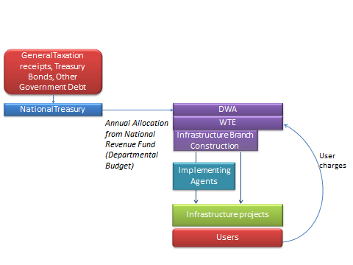

This option has advantages in the institutional simplicity of using existing institutional arrangements, the range of infrastructure that can be financed and ensures that decisions are aligned with water management policy in DWA. It is important to acknowledge that DWA itself cannot raise finance from commercial sources, but can build a capital reserve from the ROA and depreciation charges collected from users of existing infrastructure, as well as use donor/green funds. There are however mandate challenges for this option around projects related to municipal infrastructure.

However, while this is typically the way in which water infrastructure is financed globally, South Africa has constraints and competition over the available capital for the significant national infrastructure programme. National Treasury has indicated that where water infrastructure can recover costs, the capital should be financed from off-budget commercial sources. In this approach, all of the financial risk resides with government, while the users carry little risk.

This option is likely to continue to be an important aspect of the entire financing picture, but needs to be targeted specifically to projects that have significant social or developmental aspects and for which other sources of financing are not readily accessible. In order to motivate fiscal allocation, it is critical that the operational efficiency of the use of this finance and the recovery of charges associated with these projects is strong.

Recommendation: This is part of the status quo, but should be combined with the off-budget financing arrangement in Option 2, as a coherent institutional option based on project financing. Improvement of operational efficiency and building of the Reserve are important aspects.

## Option 2: Ring-fenced Project with Commercial Financing

The nature of water resource infrastructure is that it often requires significant investment, over a multi-year period. It therefore lends itself to the establishment of a dedicated ‘Special Purpose Vehicle’ (SPV), which obtains funding for the capital investment from external sources on the strength of the underlying project. These sources will include debt in a variety of guises such as commercial loans, bonds, and development finance loans (World Bank, DBSA, etc.).

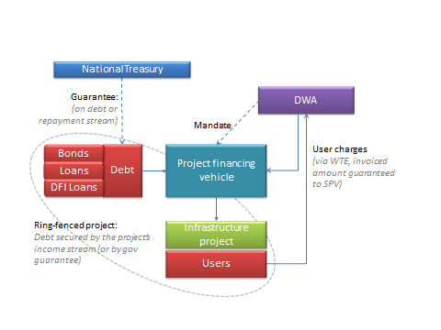

The TCTA is the prime example of such an SPV, and o this model requires little institutional change. In practice, the project SPV may require support from government in the form of guarantees to the lenders, either on the debt itself (as in the case of LHWP) or implied in the revenue associated with the asset collected by DWA. This implies that the debt in the SPV is a contingent liability on the National Government balance sheet, while the financial risk for revenue collection remains with DWA. The financial institutions and users carry little risk, so ideally this implies that the cost of capital should be low.

Where there is a significant portion of project water users that cannot afford the scheme at its full cost of capital or they will only be available in the future, fiscal grants (or other developmental soft loans) will be necessary to support the commercial financing. While the SPV can access most sources of finance, it cannot use existing revenue to leverage new finance, nor can it build reserves from other assets. This can be partially overcome by pairing this option with the DWA option described above, particularly if greater operational efficiencies are achieved.

The SPV only acts under mandate from the Minister (and DWA) on specific projects and the operation of the system is done by DWA or other infrastructure utilities (eg. Water Boards), so the alignment with broader water management imperatives is easily maintained. It is also quite flexible on the types of infrastructure that can be financed, as long as the income stream is clearly defined and is reliable.

Recommendation: This cannot replace Options 1, but provides access to off-budget financing under the status quo in a coherent institutional arrangement. Clarifying the distinction between investment grade portion of projects and the social element should be considered.

## Option 3: Project Financing Entity with Revenue Collection

An opportunity exists for DWA to channel a dedicated cash flow, such as the income collected from the Return on Asset charge into a development financing entity. On the back of this relatively secure and known income stream, the entity would be able to approach the markets for funding of infrastructure projects that may not suitable for ring-fencing on their own (e.g. due to delayed income projections, or heavy weighting of the social component). The dedicated income stream from the ROA, which has a revenue history attached to it and which comes from a wide range of assets and users (not just those linked to a particular scheme or region), should provide potential lenders with a measure of comfort as to the future projections of income. This represents the establishment of a virtual balance sheet.

The size of the total debt that can be leveraged will then depend on the size of the income stream (already) available for repayment, as opposed to the projected income stream that may materialise from the infrastructure to be invested in. Over time, income from new projects would be subsumed into the revenue stream. The operational efficiency associated with the management of revenue is fundamental to this model, so the collection of charges would probably need to be a core function of this entity, with the transfer of O&M charges to the DWA infrastructure management component. It may even be that strategic asset maintenance should be overseen by this entity in the interests of protecting assets and revenue, which would imply decisions around the disbursement of the depreciation charge would be the responsibility of the entity.

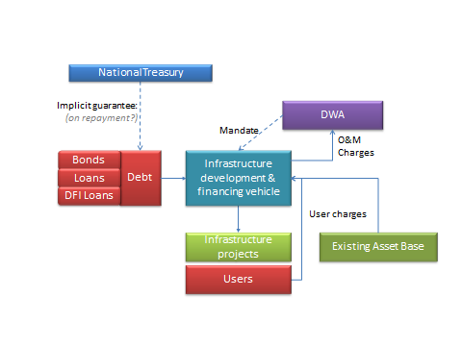

The aspects of project mandate and operational alignment are similar to the previous option, with DWA and other utilities still operating the infrastructure. The important difference is that it provides more flexibility in the sources if finance, because this is based on the entire balance sheet of the entity and it is possible for the entity to build reserves for future expenditure. Putting all of the development financing and revenue collection in one entity also ensures coherence between projects’ financing and development. Depending upon the arrangement of the entity, this option may reduce the risk to government, as well as the contingent liability for any debt.

It would however require the establishment of this entity with control over the national assets and responsibility for revenue, which would probably require a legislative process (or amendment of TCTA mandate).

Recommendation: The critical challenge with this model is the split between financial management and operations, which would create too great a risk (uncertainty) and negate the benefits of a single balance sheet. This option is not practical and balance sheet funding actually requires the existence of the infrastructure utility outlined in Option 4.

## Option 4: Infrastructure Utility with Balance Sheet

The concept of infrastructure utilities that finance, develop and operate infrastructure off the strength of their balance sheet and revenue is well established globally (and in South Africa in the water boards). While it has been on the national agenda for many years, there is no national utility for water resources infrastructure, but rather water boards for bulk water services infrastructure that also operated water resources infrastructure. This option reflects the establishment of a national infrastructure utility (agency) or regional utilities (water boards) with potentially expanded mandates for the development of a range of water resources infrastructure types. It has the advantage over DWA as operator, as it can more easily develop and operate projects that are linked to municipal systems (under contract), thereby avoiding challenges in terms of constitutional mandates.

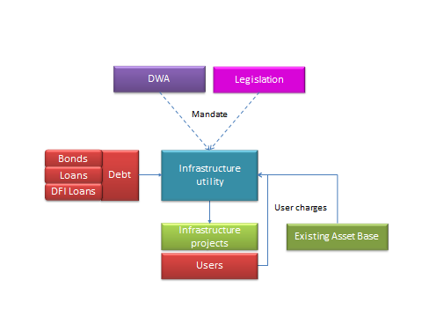

This option has advantages around risk, sources of finance and institutional coherence, but does raise challenges around the alignment between operations and water management imperatives. However, infrastructure development will continue to be under mandate, tariff setting would be regulated and the system operations will be specified by the Minister and DWA, so governance mechanisms would ensure alignment.

Recommendation: This option provides the only practical approach to financing new infrastructure from the revenue stream and reserves of the existing asset (balance-sheet); it may relate to existing water boards or a new infrastructure entity. This requires the development of demonstrated operational efficiency, transparency between investment grade and social infrastructure, and clear governance around the Ministers mandate to build infrastructure and the associated operating rules.

## Option 5: Public Private Partnership with Shared Equity

For projects with a dedicated revenue stream, it may be appropriate to explore a partnership (with associated special purpose vehicle) based on shared equity between government and financiers. As the cost of equity tends to be higher than the cost of debt, this would be more applicable to schemes for which the investment risk is higher (but can be recovered if managed efficiently).

This may be relevant for specific non-conventional infrastructure that has potentially dedicated customers (such as a desalination plant), is an add-on element of an existing system (such as pressure reduction on municipal systems) or has possible beneficiaries that would pay (such as a mine dewatering and treatment). It is less likely that government would want to share equity risk on more traditional strategic infrastructure that is part of wider water resources and supply systems, because those with higher risk are usually associated with affordability of supply to poor communities, which should not be solely linked to equity profit objectives.

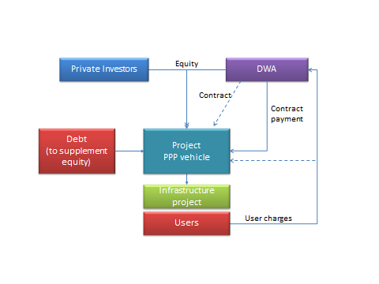

For this option to be warranted, the equity returns would need to be linked to risk around the achievement of performance targets or associated with revenue collection rates from uptake. The rationale for government involvement rather than a concession arrangement would be related to a government’s strategic objectives, but not be in governments’ core responsibilities or capacity. The private partners would need to bring specific technical or management expertise to the partnership.

The institutional complexity of these arrangements requires a dedicated vehicle, with sophisticated governance arrangements and transaction costs to ensure that the partners’ returns reflect risk. Thus it would only be warranted for larger projects with significant financing requirements, or projects in which the private group provides equity to add infrastructure to an existing system (so the public partner brings control over the existing asset as the equity). These partnerships can also access debt finance and possible donor funds, but typically do not have the opportunity to access prior reserves (unless these are brought in as equity by one of the partners).

There is a concern about alignment with broader water management objectives, but this is less problematic for stand-alone non-conventional infrastructure, and any interface would need to be clarified in the operating rules and agreements between the regulator and the partnership entity.

Recommendation: Water is a strategic resource and in South Africa cannot typically support or justify the higher rates of return required for private sector equity stakes. Extensive private sector ownership or management of water resources infrastructure is not envisaged, but partnerships (while imposing significant governance and risk complexities for the public sector), may represent a possible institutional mechanism for financing specific types of infrastructure projects within a broader public-sector institutional arrangement, linked to Option 6.

## Option 6: Private Concession

Under this option, authorisation for a project is provided to a private company (or consortium) that undertakes to finance, develop, operate and maintain it to pre-determined specifications. Transfer of the assets may take place at the end of the contract; this would generally be after a relatively long time period, to enable the private contractor to recover its investment in the infrastructure. The private company would have control over financing decisions and development in accordance with the concession agreement, while operations and tariffs would be negotiated annually according to the agreement and government’s broader strategic water management objectives.

For this to be appropriate, the operating entity would need to bear some risk over the reduction of costs or recovery of revenue. The sources of revenue may include all 5 types identified above, depending upon the nature of the infrastructure and its purpose, with fiscal support possibly being provided to ensure the viability of a project with social or developmental dimensions.

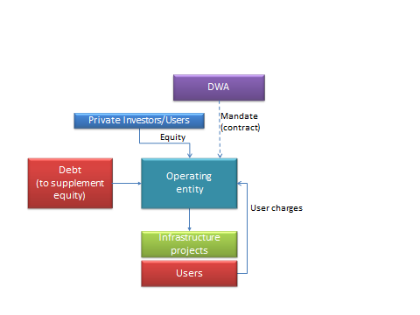

For the same reasons highlighted for the partnership option, non-conventional infrastructure would be more appropriate for this option, although single purpose water resources infrastructure that serves a group of users may also be relevant (such as irrigation or small local hydropower schemes).

There are questions about the concessions for large water resources infrastructure, particularly within broader supply systems, largely related to the alignment of private management interests and public water management requirements for a strategic resource. This challenge can be relatively easily solved at a local level through operating rules and dedicated revenue streams, but are complicated where multiple schemes supply multi-purpose users.

The institutional complexity for government of these types of arrangements is in the development and oversight of the agreement, with the private partner taking the responsibility for the establishing their development / operating entity. This option may however be implemented jointly by a group of users through an institutional mechanism such as a water user association (legally recognised by the Minister under the National Water Act) with a strong balance sheet or surety by the individual beneficiaries, in which case the asset may stay with that entity in perpetuity.

Recommendation: The cost of equity and strategic operational alignment challenges mitigate against widespread private concessions for water resources infrastructure. However, private concessions are likely to be an important mechanism for non-conventional infrastructure projects, such as effluent/decant treatment, waste water reuse, sea-water desalination, water conservation/demand management interventions or micro-hydropower. These would take place within a more general public-sector institutional-financing arrangement, with attention required to clarify issues of operational alignment, service standards and contractual financial responsibilities.

# Recommendations for the Way Forward

The primary purpose of this note was to frame a discussion with the financial industry around the suitability, opportunities, risks, challenges and requirements of each of these options to meet the infrastructure development requirements of South Africa over the next couple of decades. Based on this input and further analysis, the following key conclusions may be drawn.

There are fundamentally only two institutional arrangements for water resources infrastructure financing:

* Project-based financing: for which projects are financed on a ring-fenced project-by-project basis according to the projected income (and/or guarantees) associated with the users of water from that scheme or system.
* Utility-based financing: for which a portfolio of projects is financed according to the projected corporate income (and/or guarantees), considering the overall financial health of the independent entity and its assets.

Either the project approach or the utility approach is compatible with public or private sector ownership. However, the strategic nature of South Africa’s water resources infrastructure and the typically long (discounted) payback periods associated with these investments implies that a predominantly public sector institutional arrangement is most appropriate. Private sector concessions or even partnerships may be an appropriate financing mechanism for specific investments in non-conventional or small local schemes, within this broader arrangement.

Under either arrangement, debt (primarily loans and bonds) will continue to play an important role in the financing of South Africa’s water resources infrastructure. To ensure that this debt is obtained at the most effective rate, it will be critical to clarify the difference between investment-grade infrastructure for commercial-economic purposes and infrastructure for social and developmental purposes, for which financing should be from the fiscus or accumulated reserves. This is fundamental to the recovery of costs and income streams, which is a key funding issue for the Pricing Strategy workstream. The approach to allocating fiscal support for capital costs and/or operating subsidies to meet social and developmental objectives must also be clarified. The principles and approach adopted infrastructure funding needs to be adopted for the financing of infrastructure.

The approach needs to be translated into transparent rules for the allocation of capital requirements between the different purposes, linked to transparent rules for the estimation of charges to recover these costs. These rules need to be adopted within the Economic Regulator models workstream, to ensure the transparent, consistent and stable pricing regime required to encourage low-interest investment in infrastructure.

In summary, the financial institutional options assessment will evaluate the implications of infrastructure financing associated with (i) the project based arrangement, reflecting the status quo of DWA and TCTA, and (ii) the utility based arrangement, reflecting either water boards or a national infrastructure entity. For each of these arrangements, different financing mechanisms, sources of capital (with varying cost of capital), and implications for water use charges (to different user groups according to the Pricing Strategy) will be evaluated, considering the medium and long term consequences for infrastructure development in the South African water sector. From this a clear recommendation will be made about the most financially efficient institutional-financial approach.

1. January 2010, Water Trading Entity (WTE) Efficiency Drive, Current Status of Infrastructure funding and water pricing in the South African Water sector